HTML

…………………………………………………………..

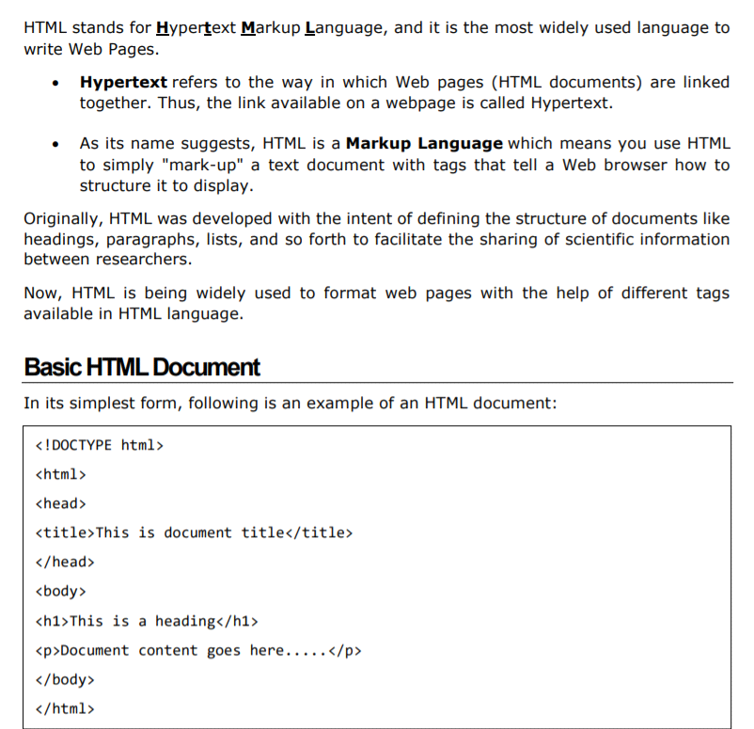

Either you can use Try it option available at the top right corner of the code box to check the result of this HTML code, or let's save it in an HTML file test.htm using your favorite text editor. Finally open it using a web browser like Internet Explorer or Google Chrome, or Firefox etc. It must show the following output:

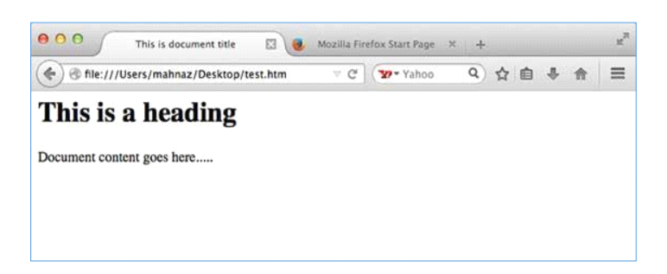

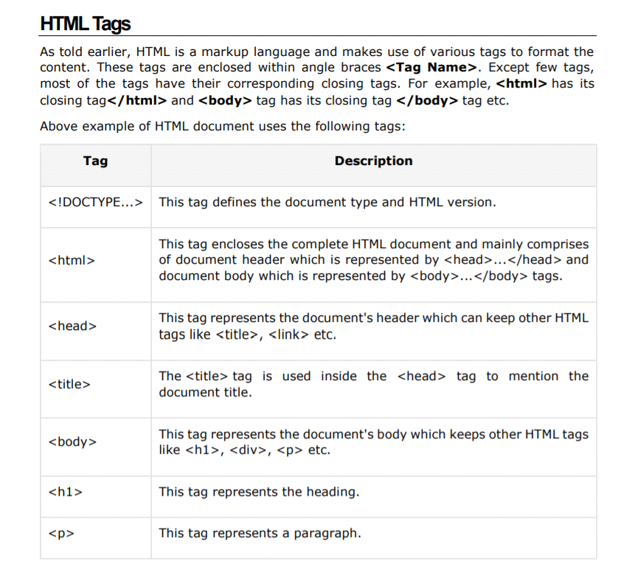

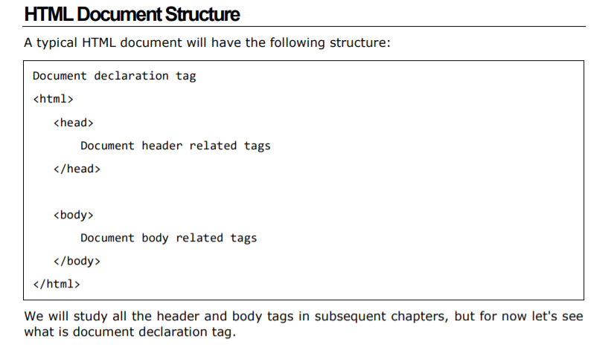

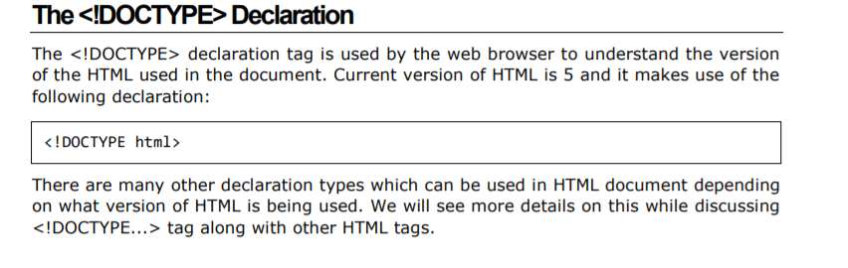

BASIC TAGS:

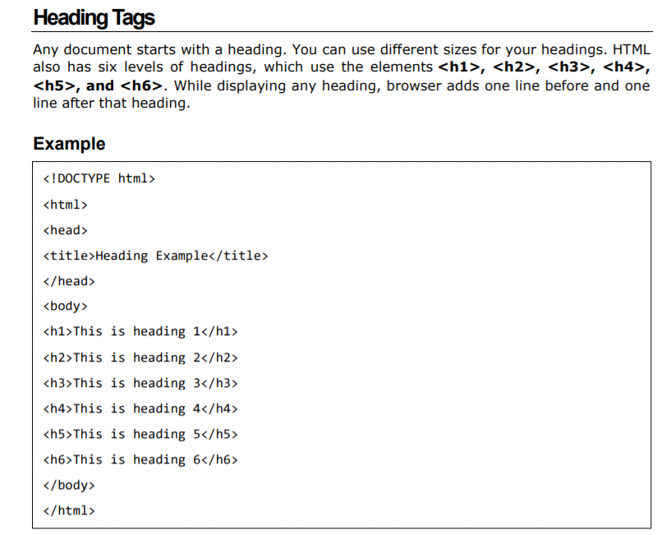

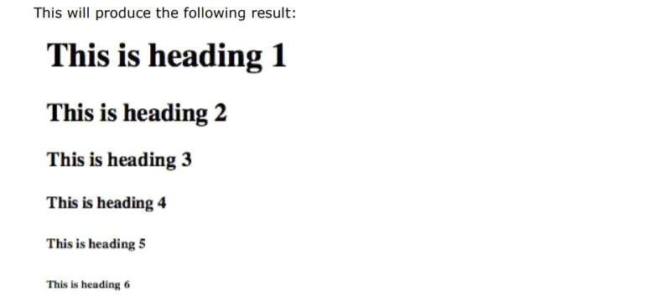

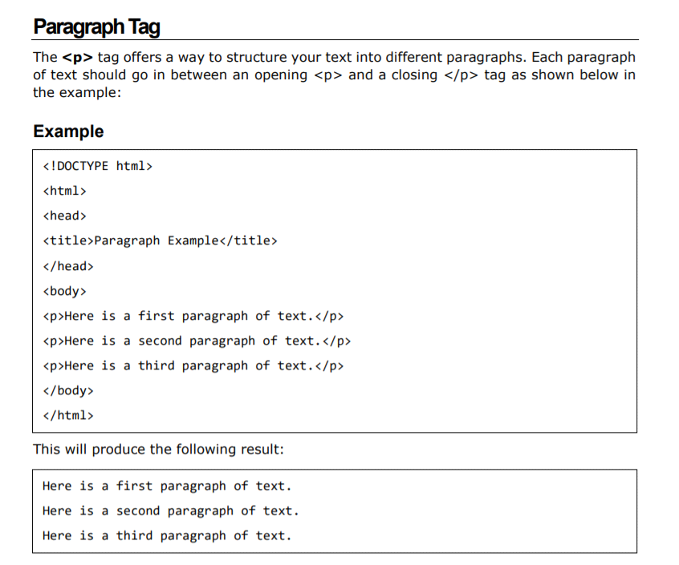

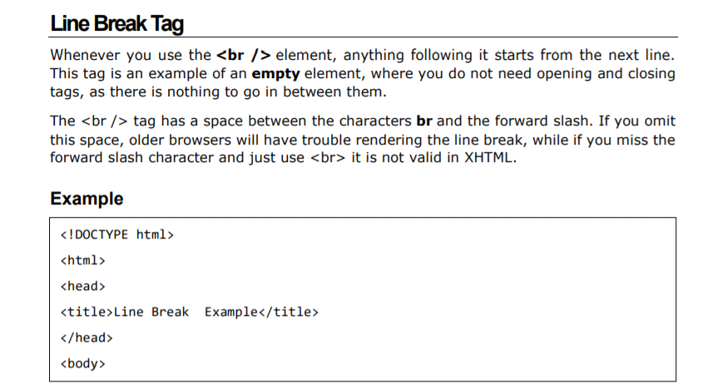

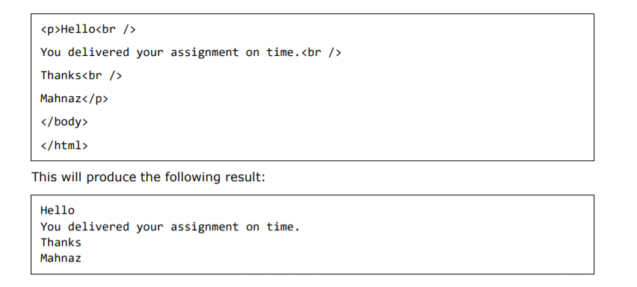

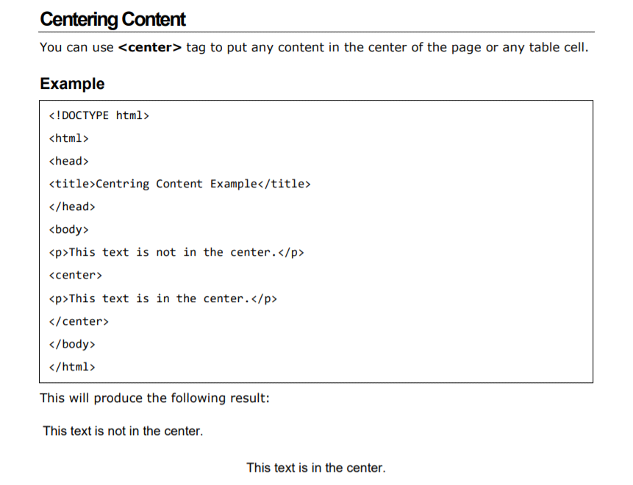

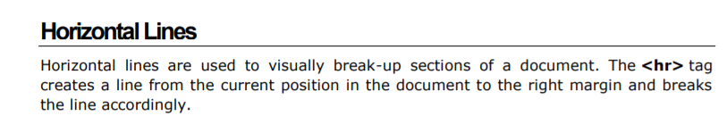

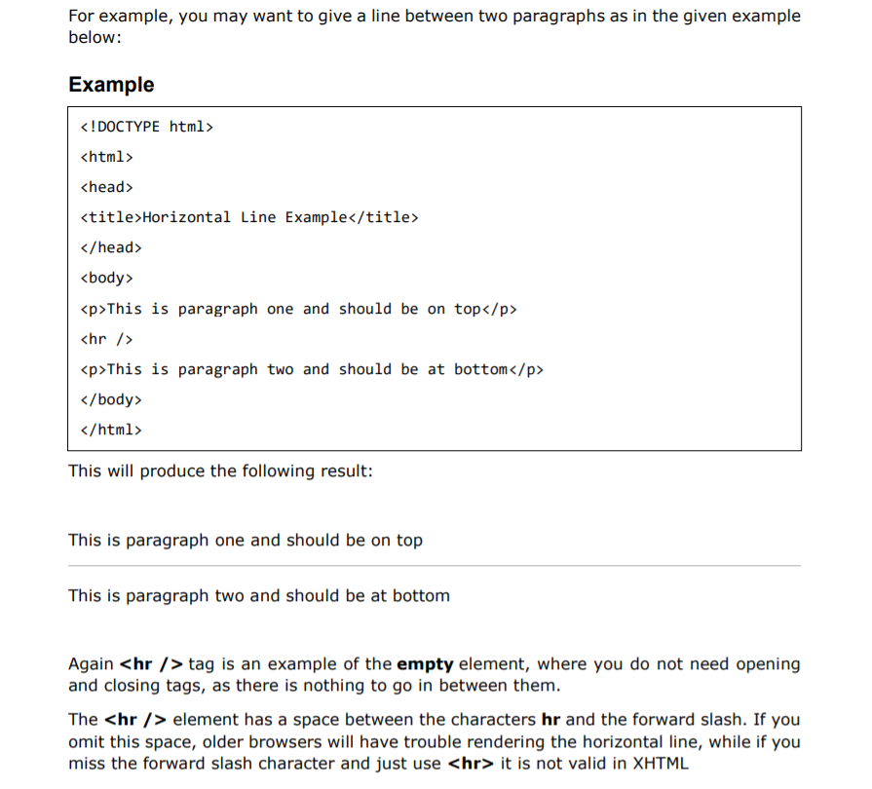

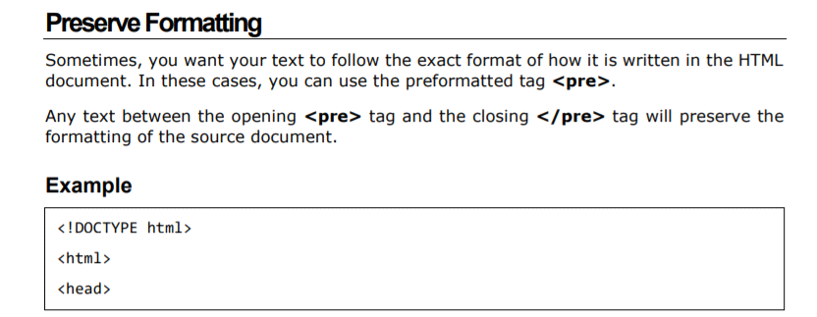

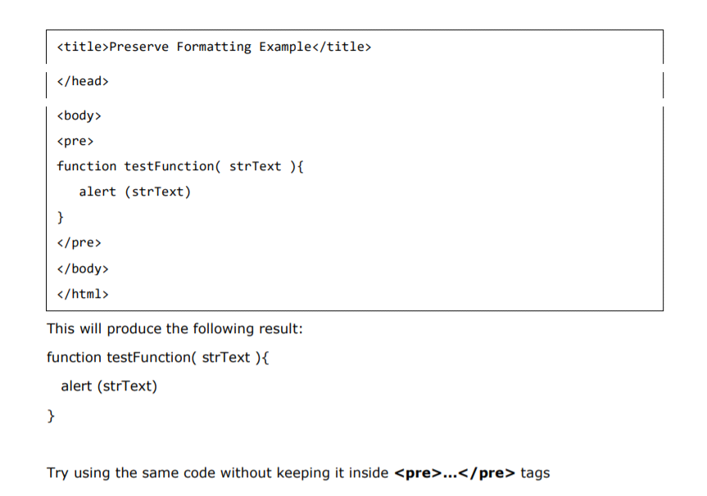

ELEMENTS:

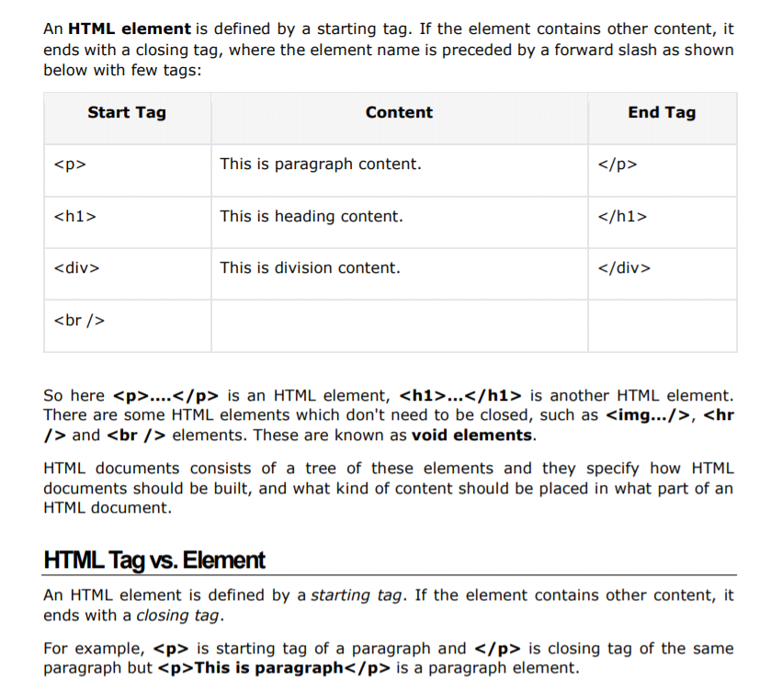

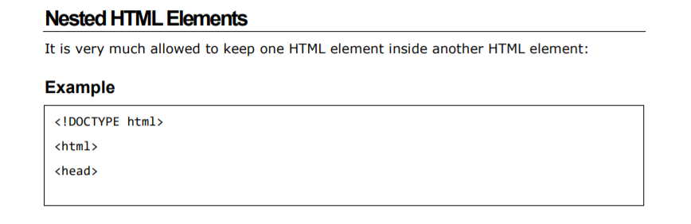

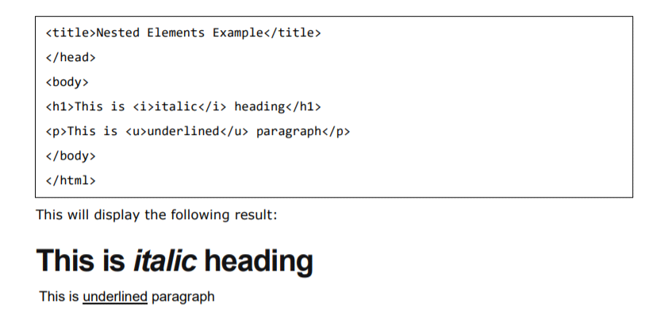

ATTRIBUTES:

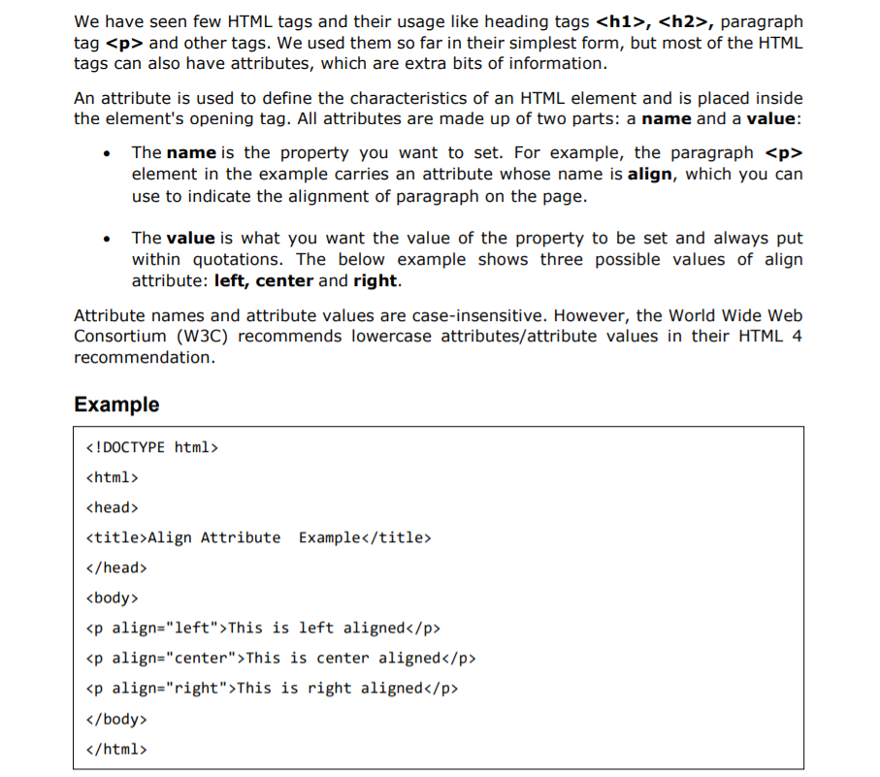

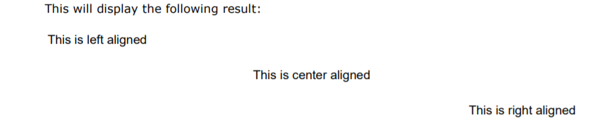

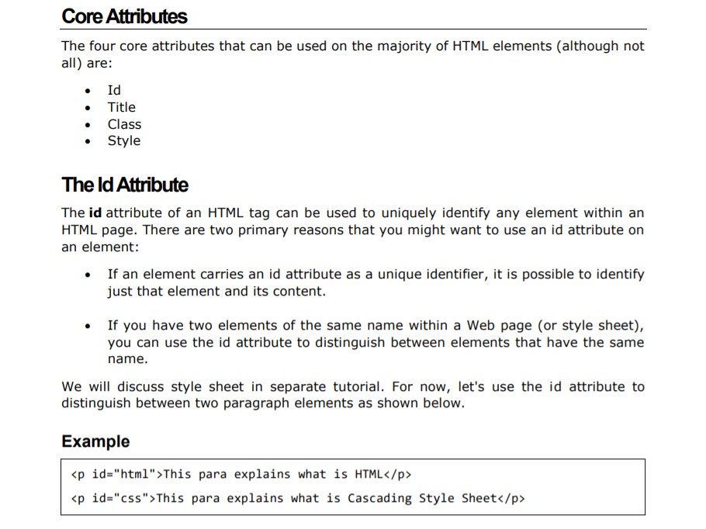

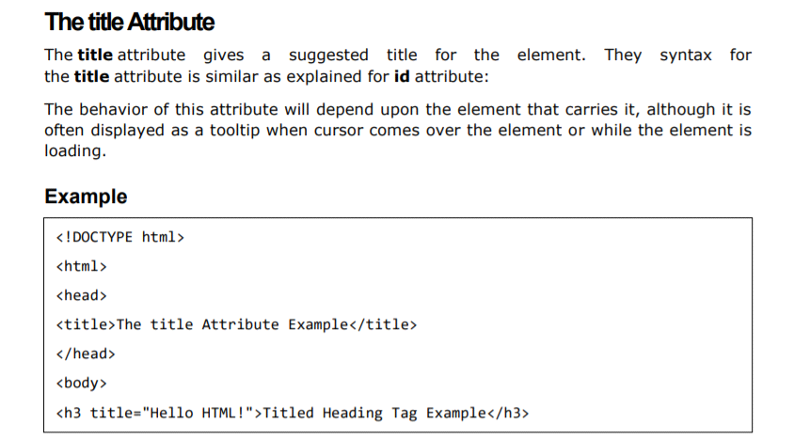

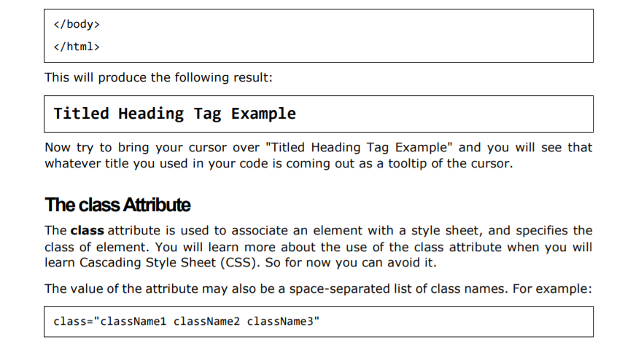

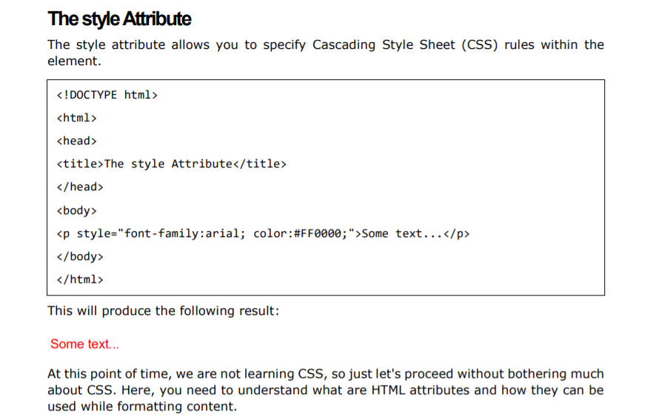

HTML COMMENTS:

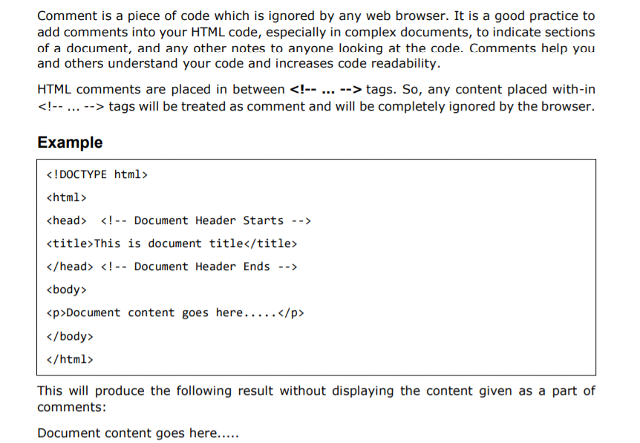

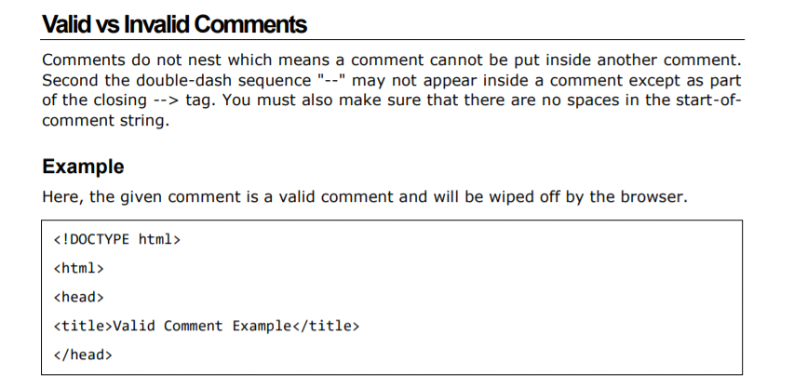

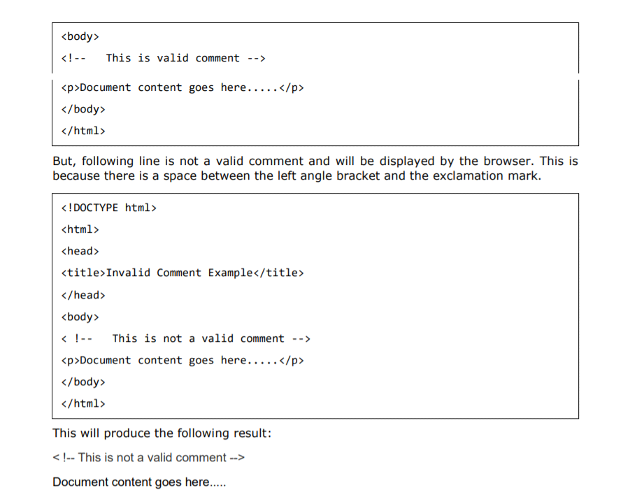

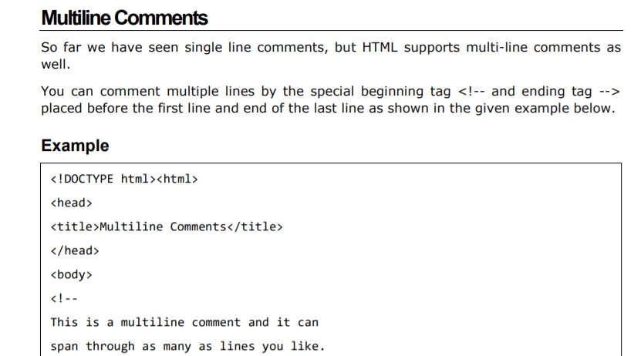

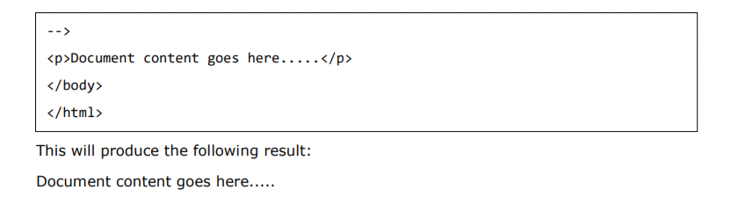

HTML IMAGES:

Images are very important to beautify as well as to depict many complex concepts in simple way on your web page.

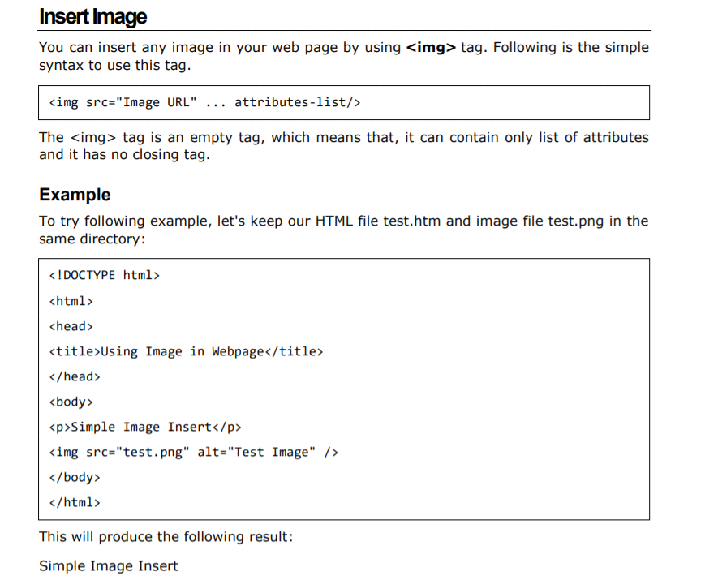

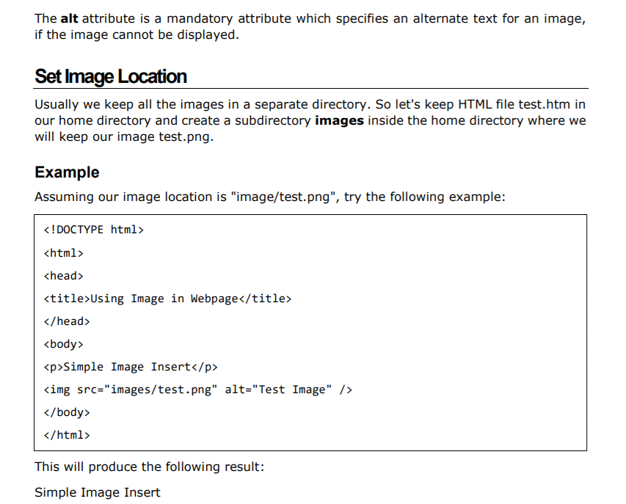

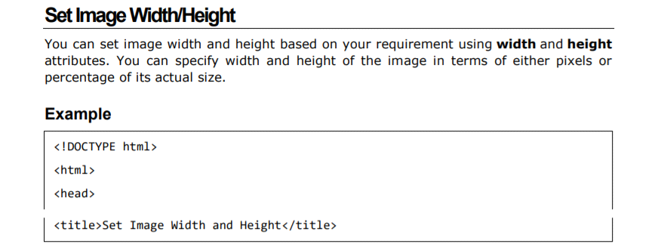

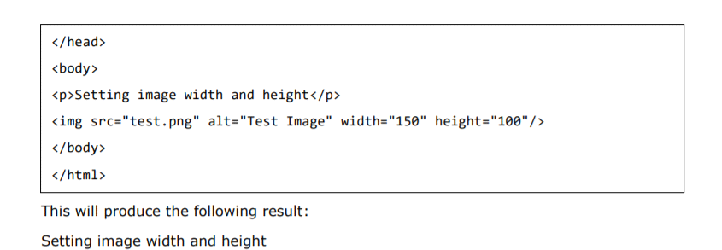

HTML TABLES:

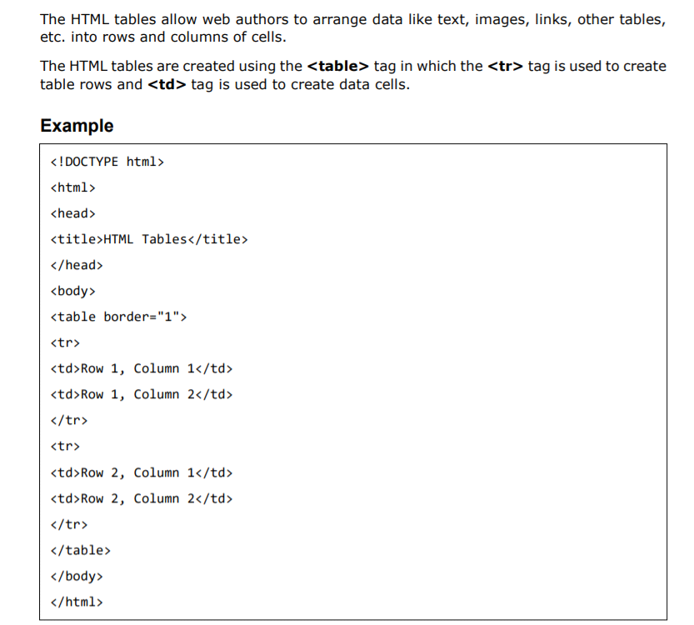

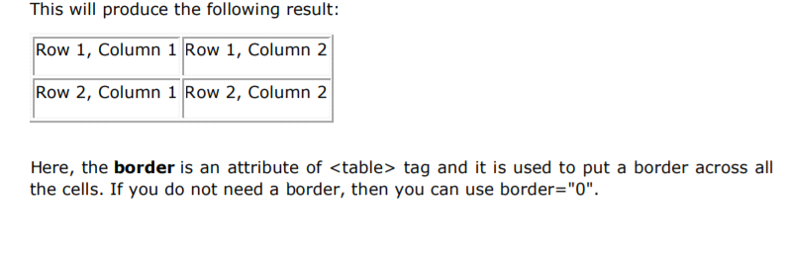

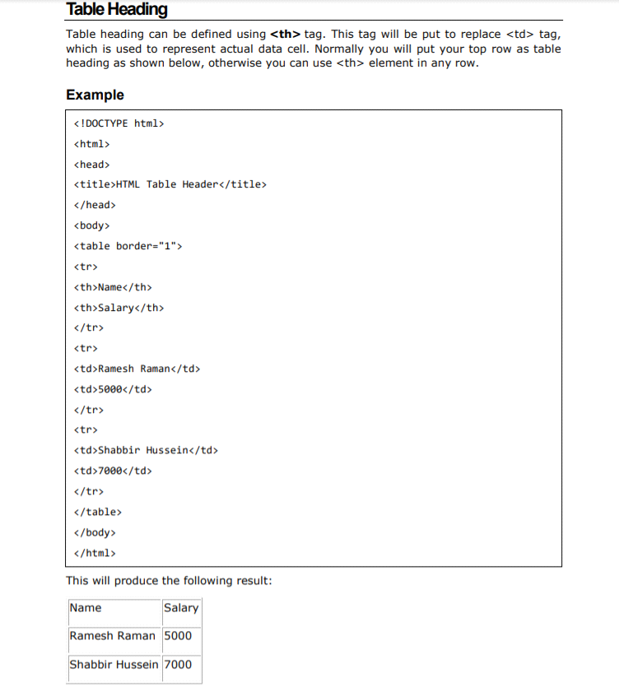

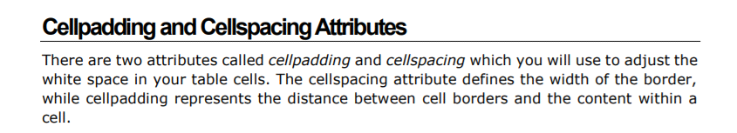

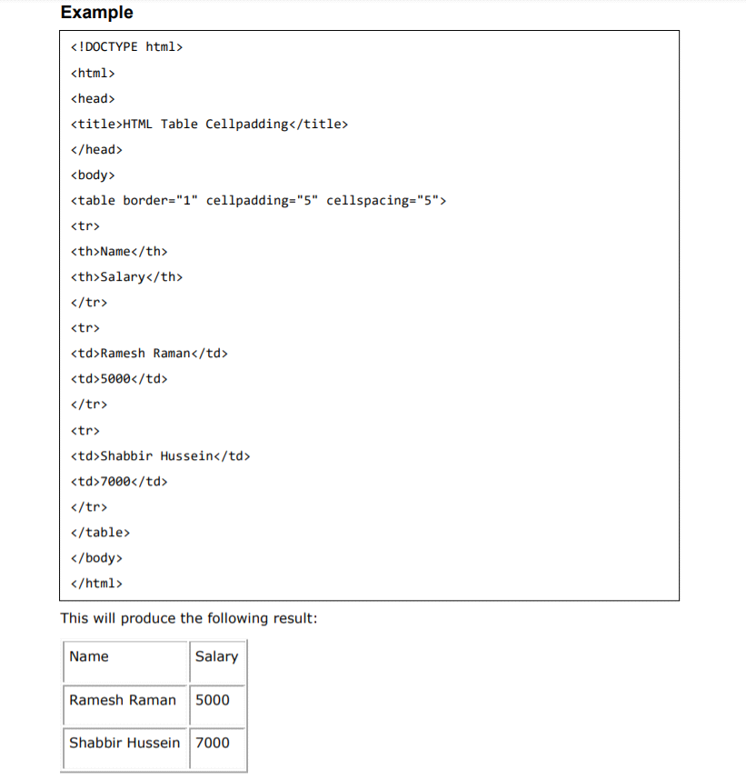

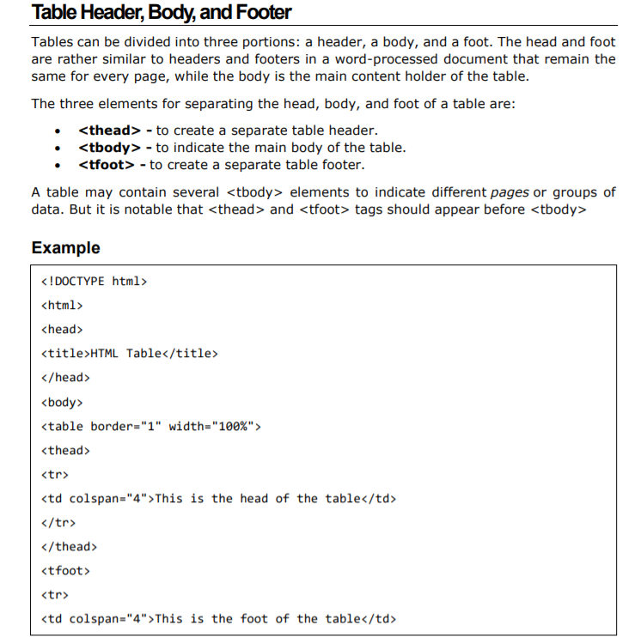

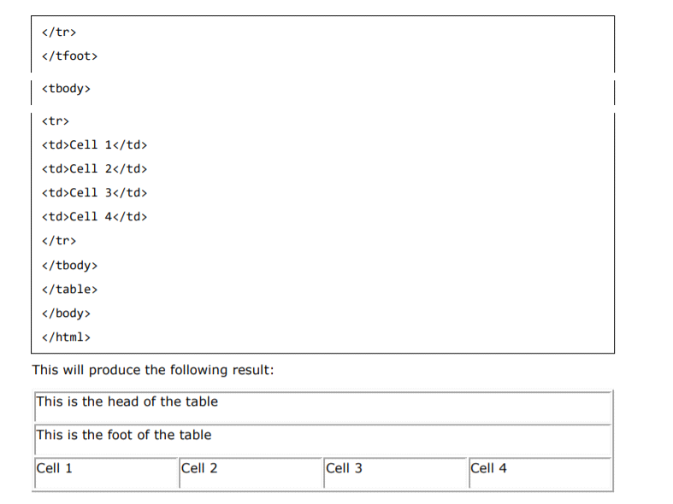

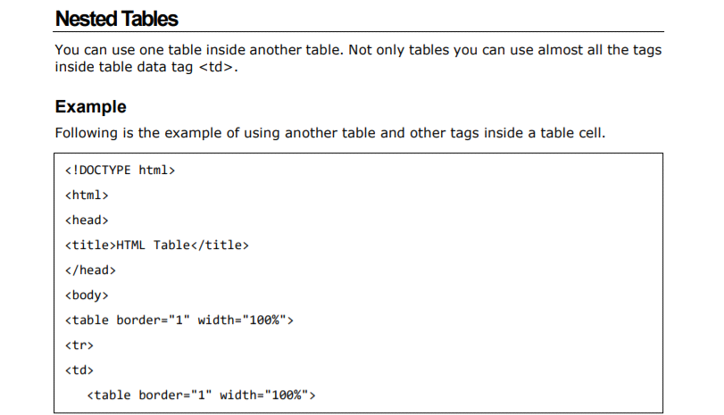

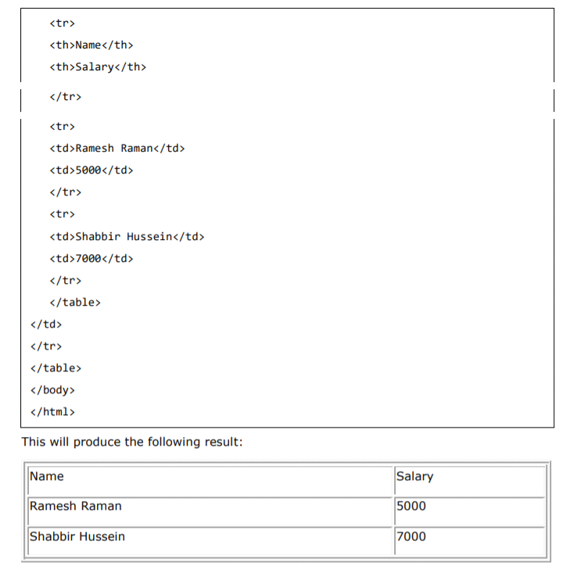

HTML LISTS:

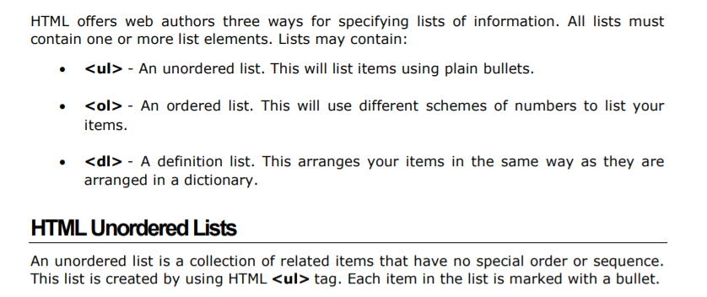

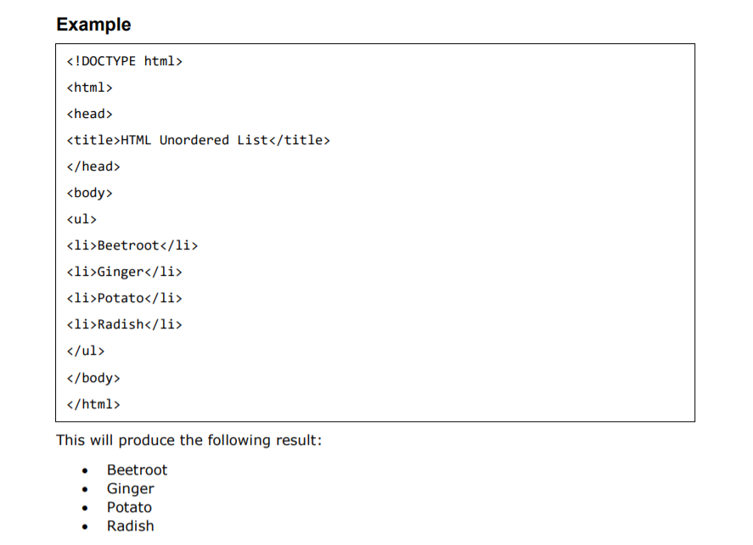

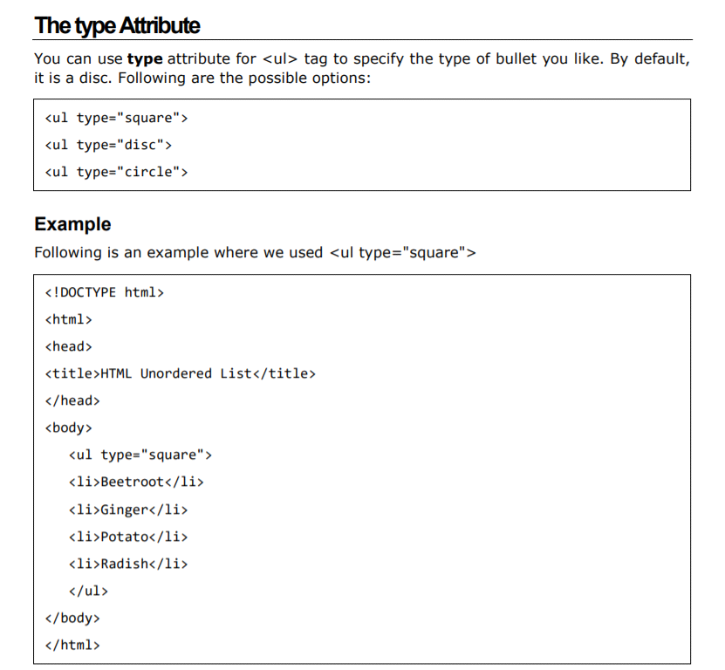

This will produce the following result:

Beetroot

Ginger

Potato

Radish

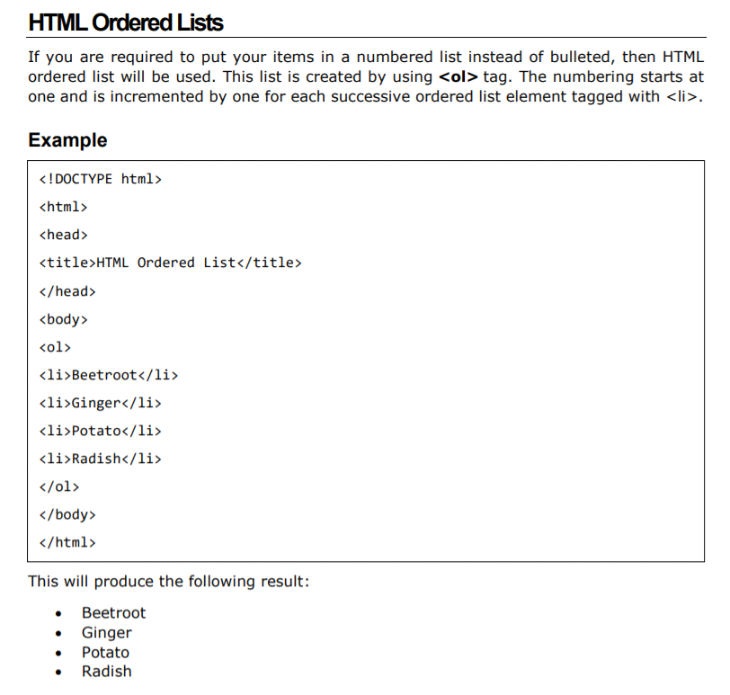

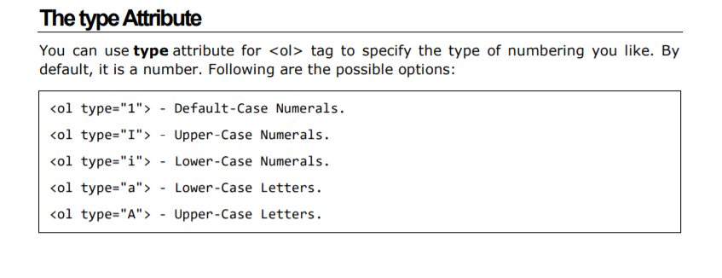

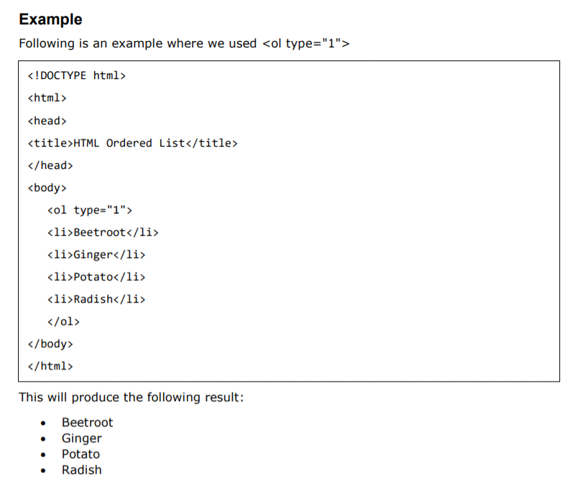

TEXT LINKS:

Hyperlinks allow visitors to navigate between Web sites by clicking on words, phrases, and images. Thus, you can create hyperlinks using text or images available on a webpage.

Linking Documents A link is specified using HTML tag . This tag is called anchor tag and anything between the opening tag and the closing tag becomes part of the link and a user can click that part to reach to the linked document.

<a href="Document URL" ... attributes-list>Link Text</a>

EXAMPLE:

<!DOCTYPE html>

<html>

<head>

<title>Hyperlink Example</title>

</head>

<body>

<p>Click following link</p>

<a href="http://www.google.com" target="_self">google</a>

</body>

</html>

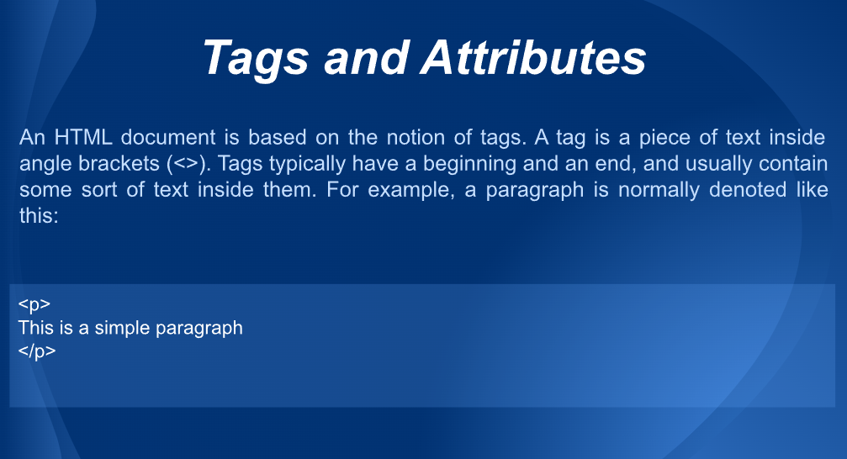

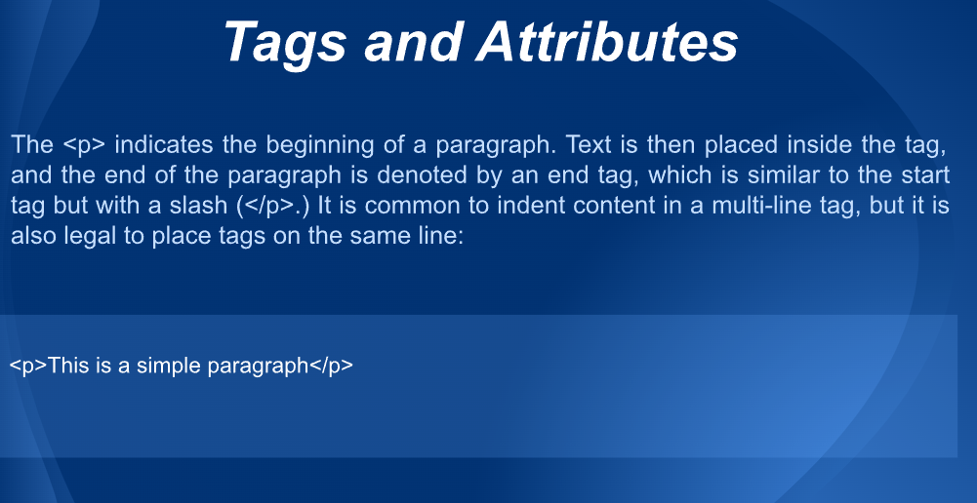

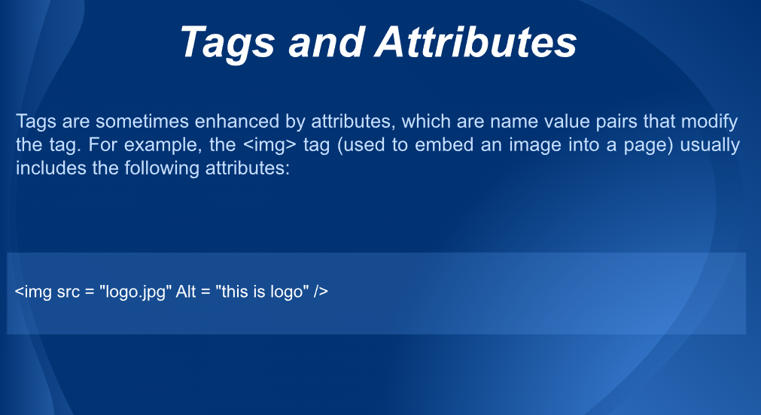

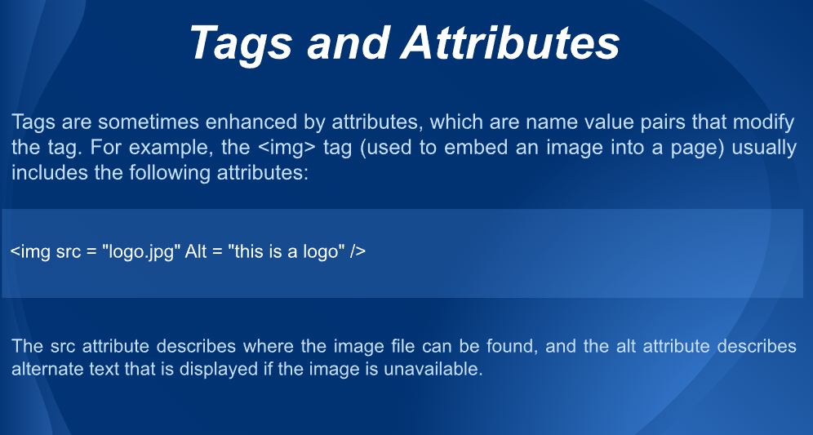

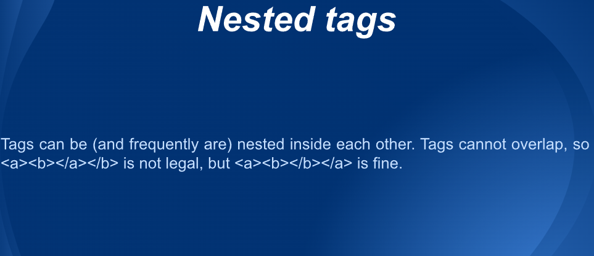

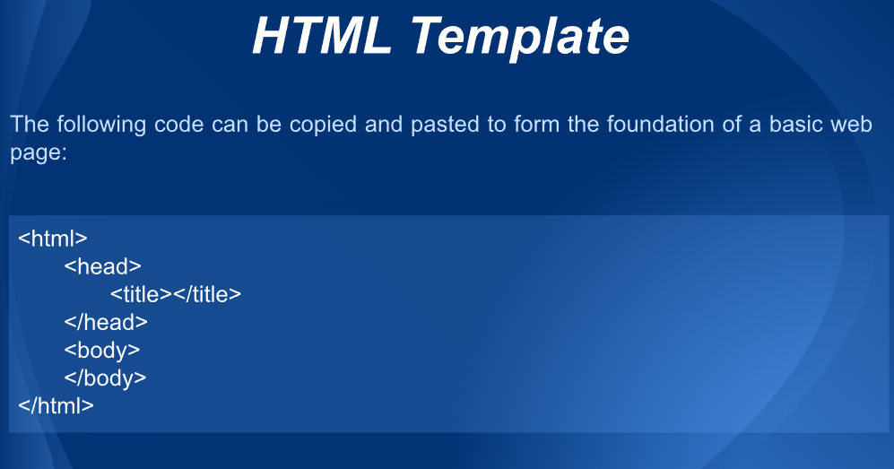

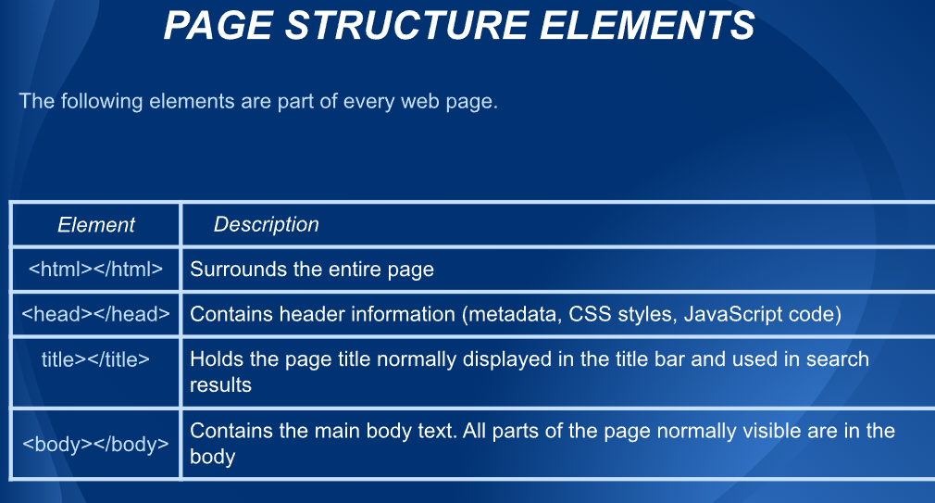

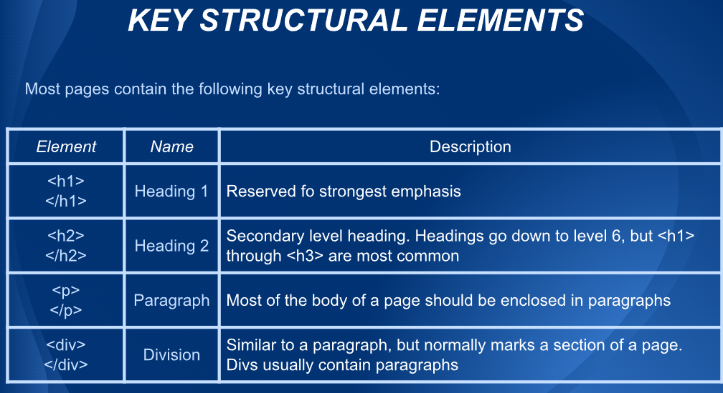

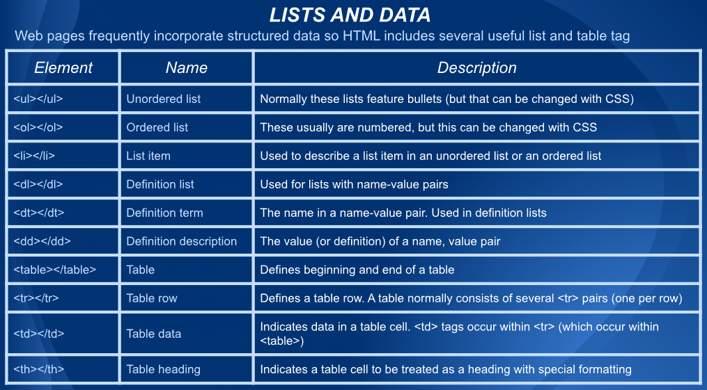

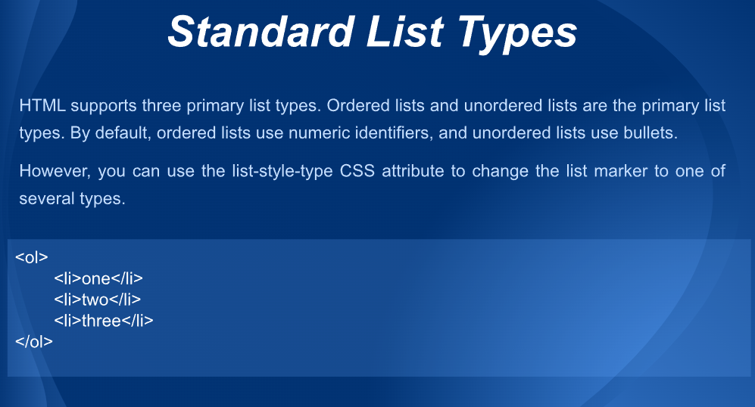

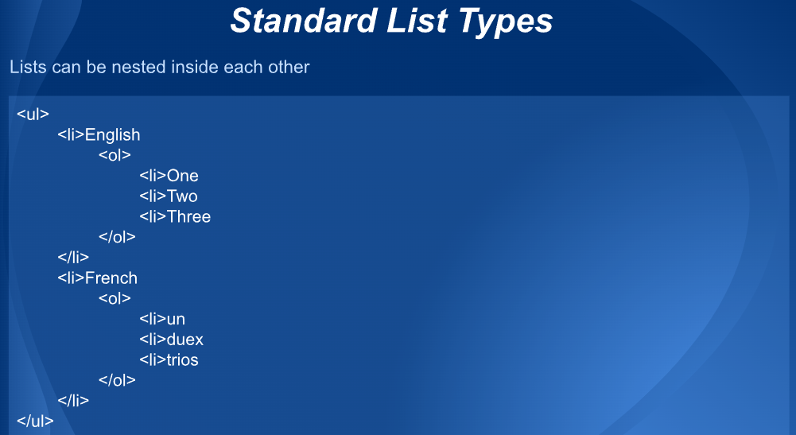

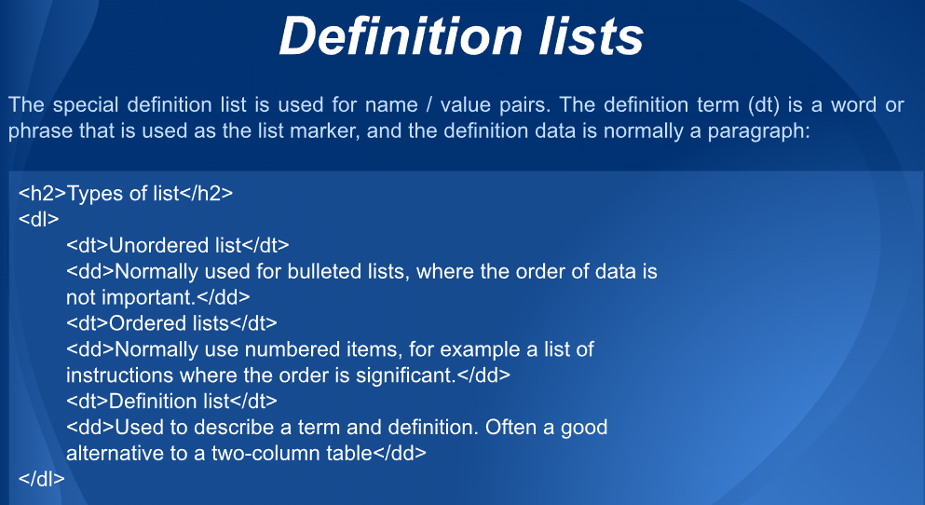

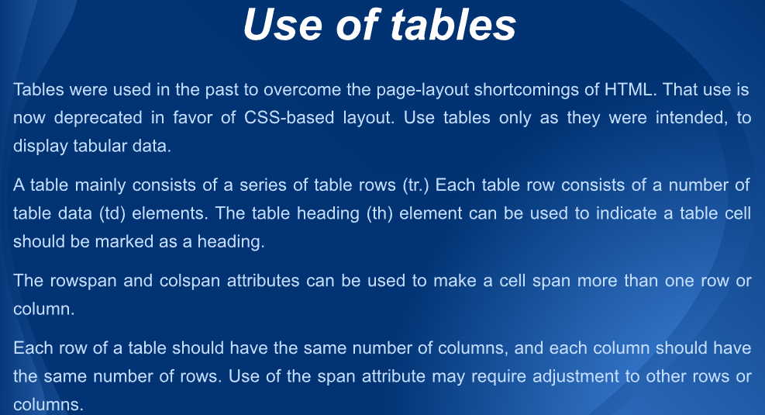

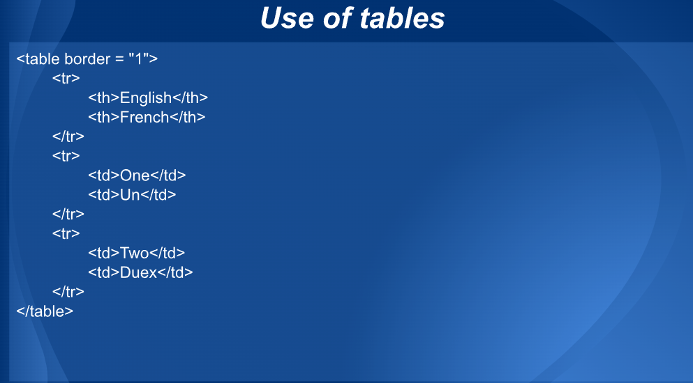

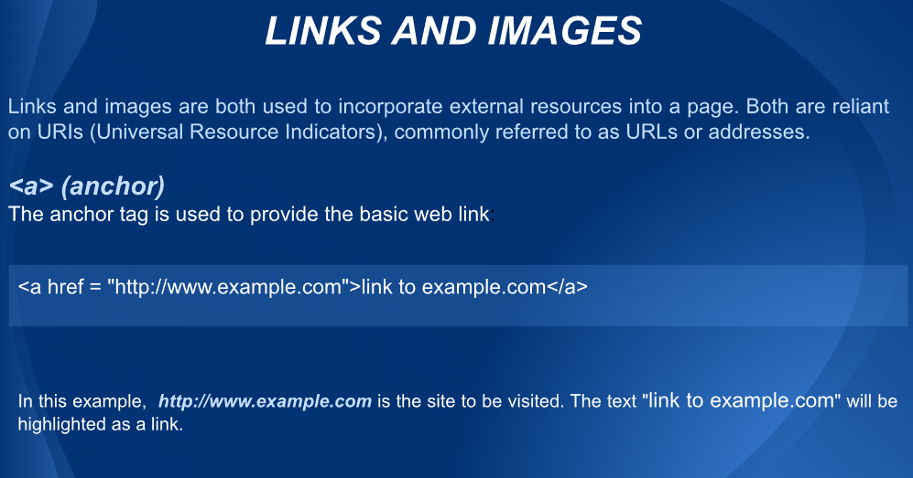

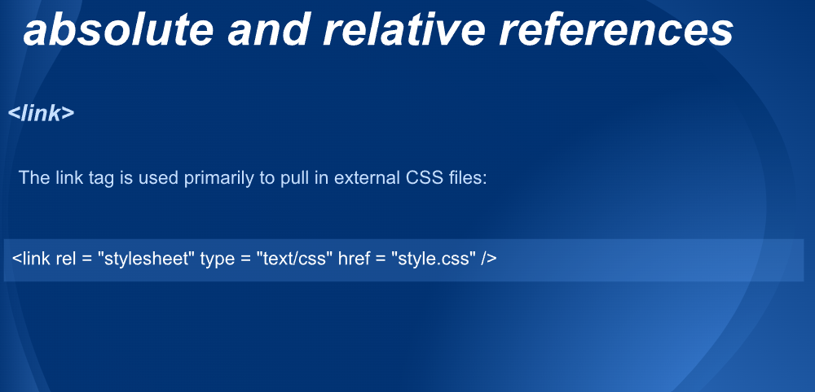

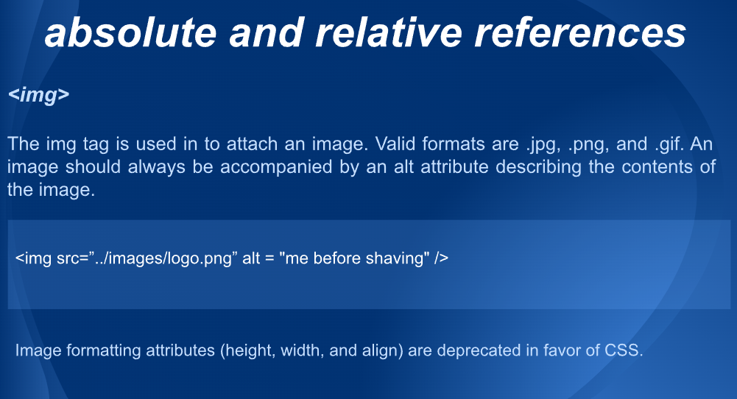

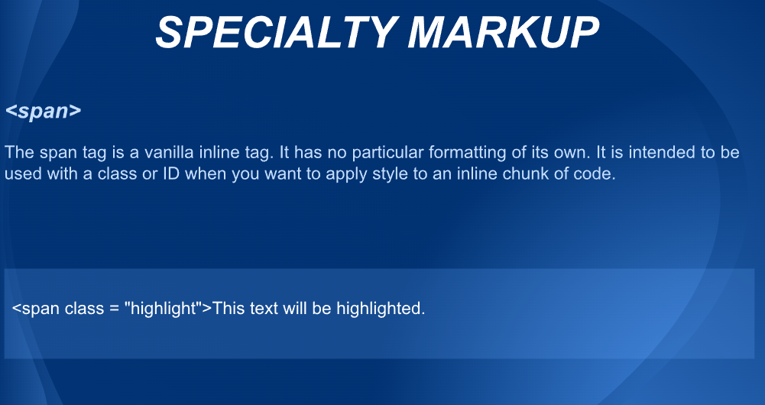

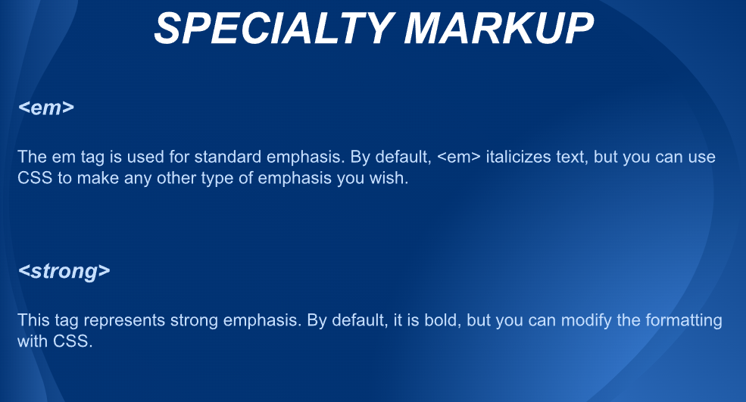

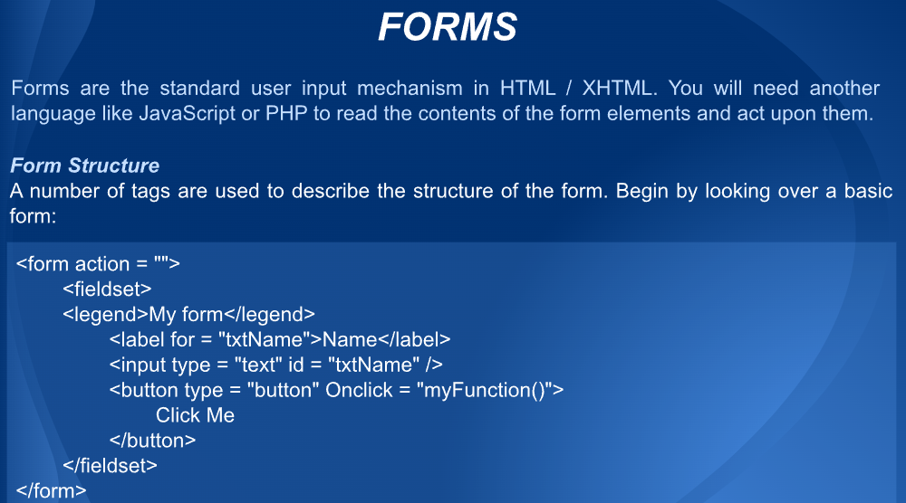

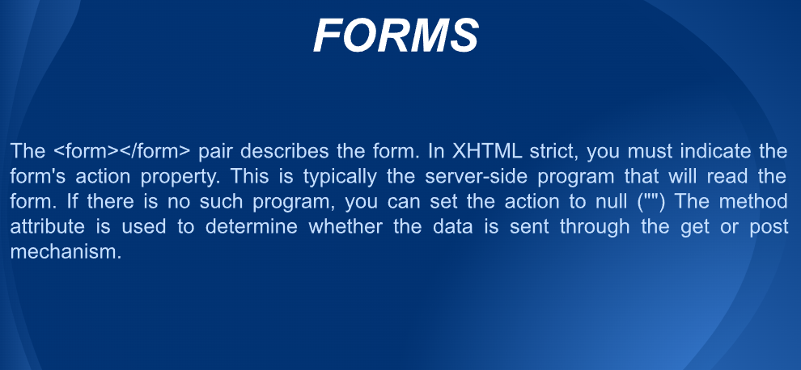

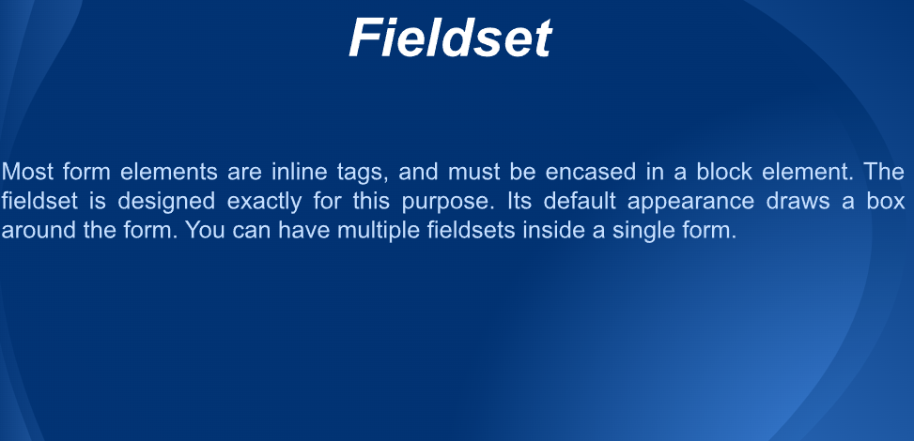

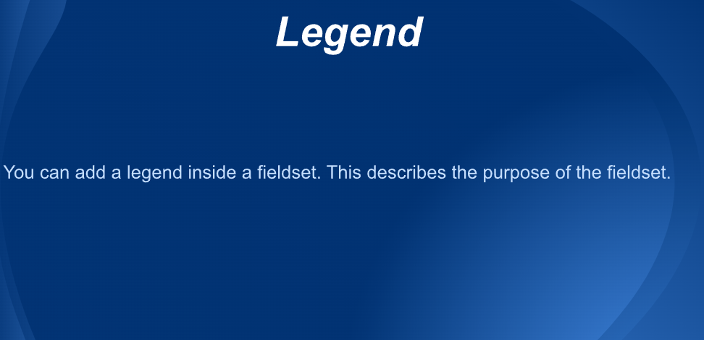

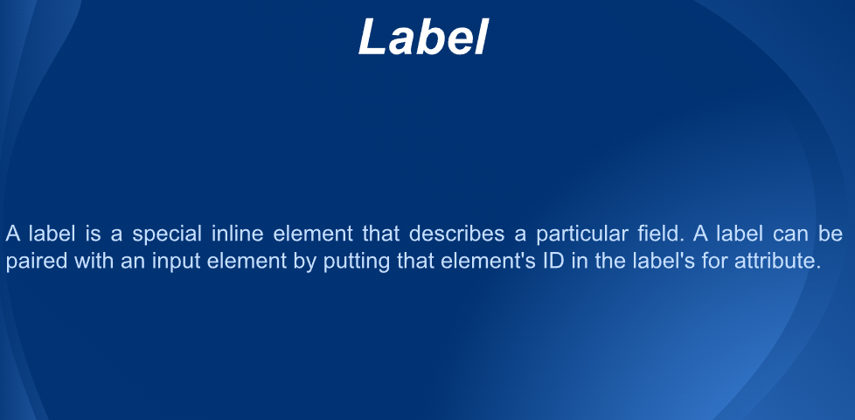

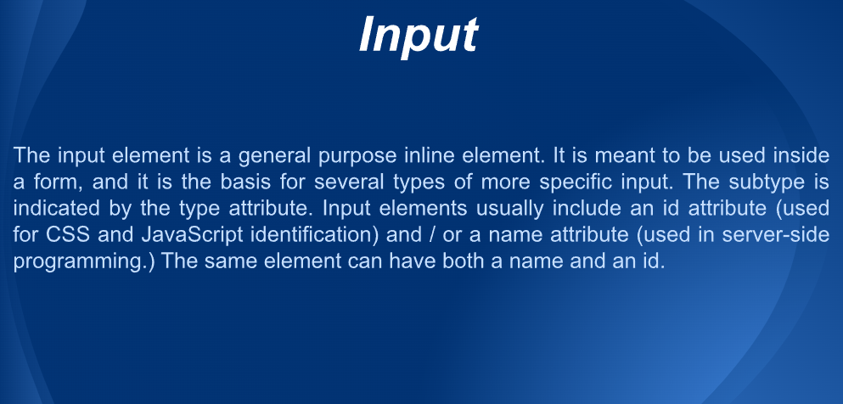

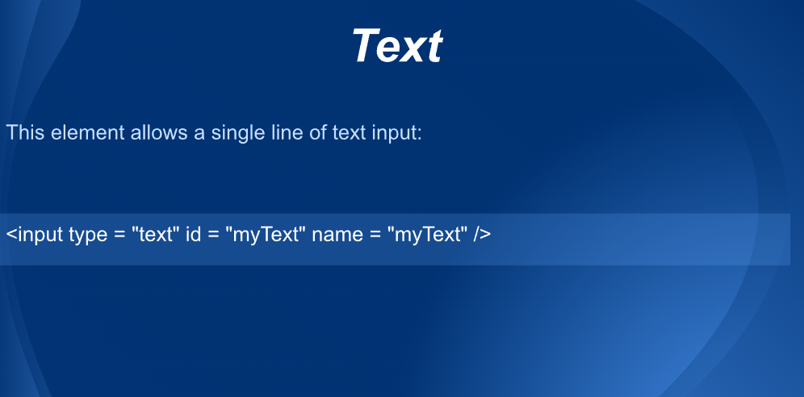

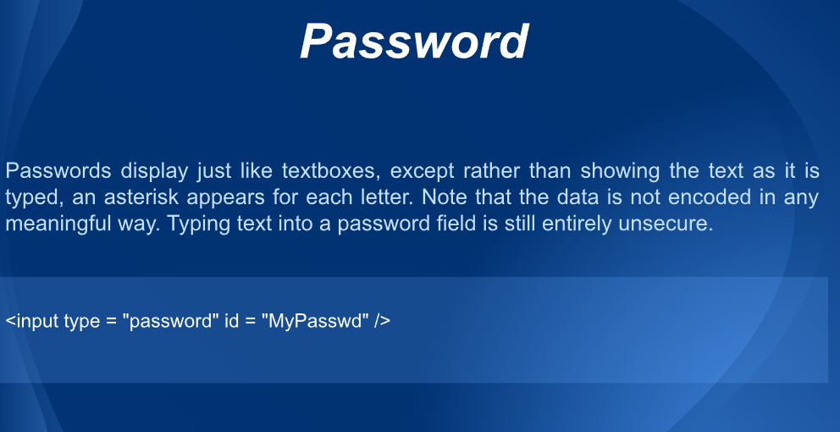

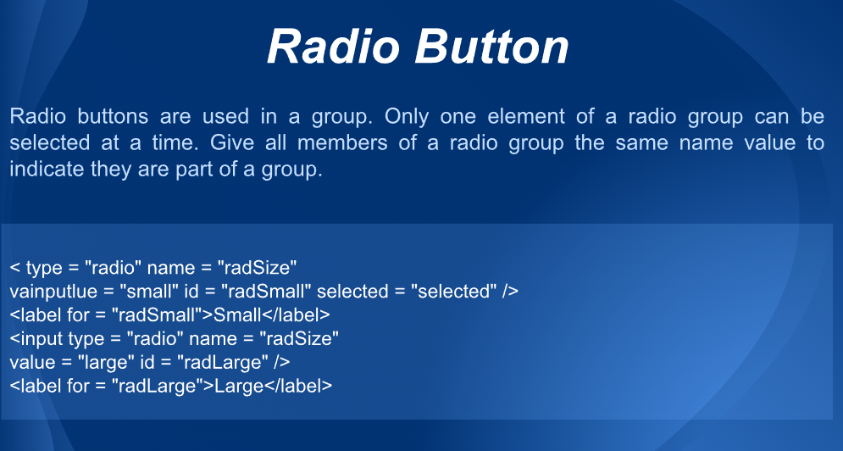

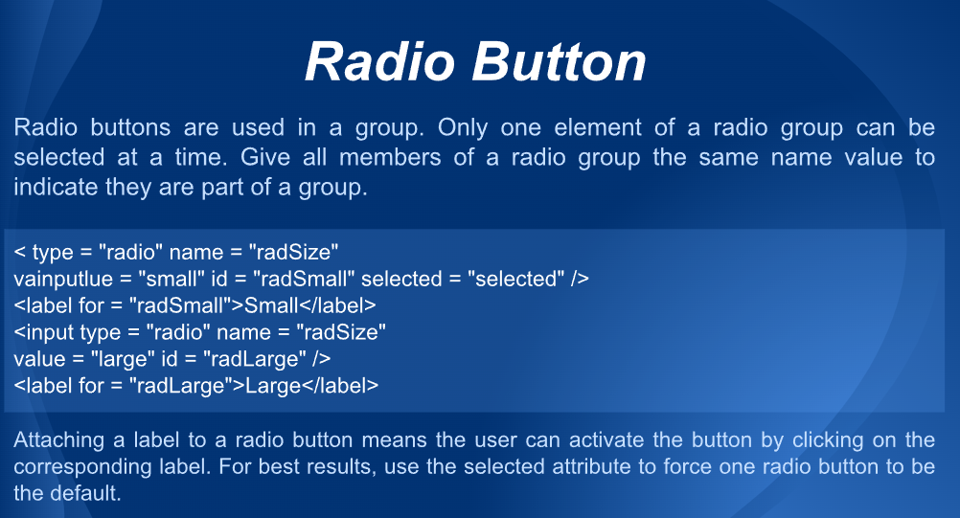

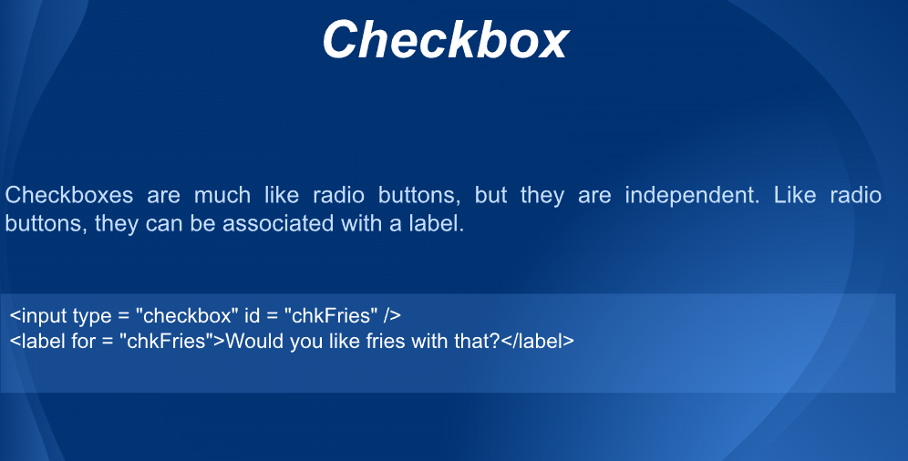

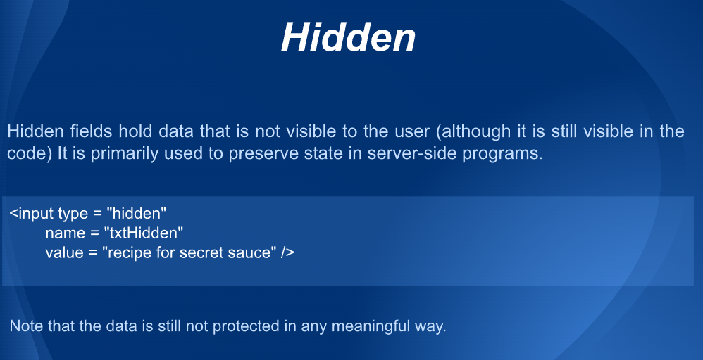

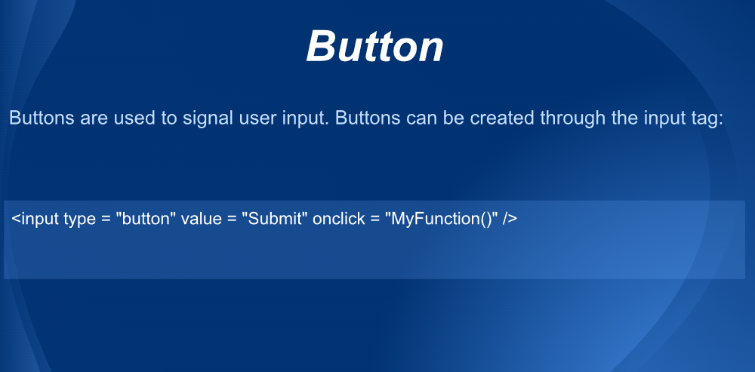

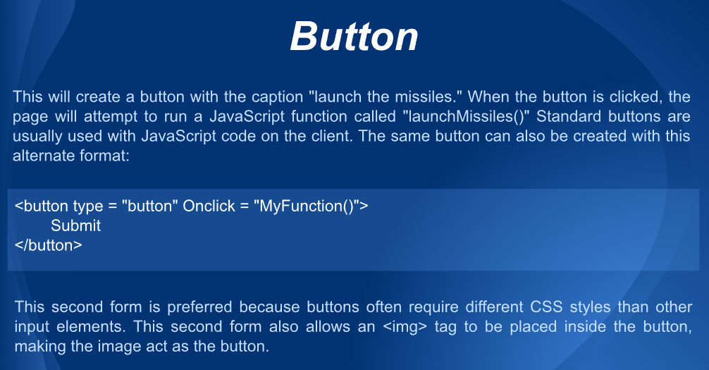

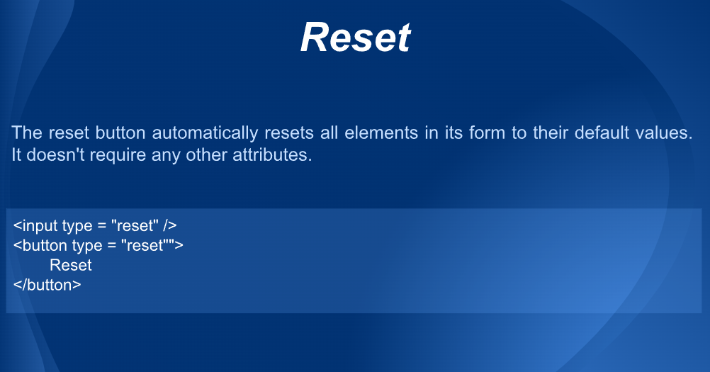

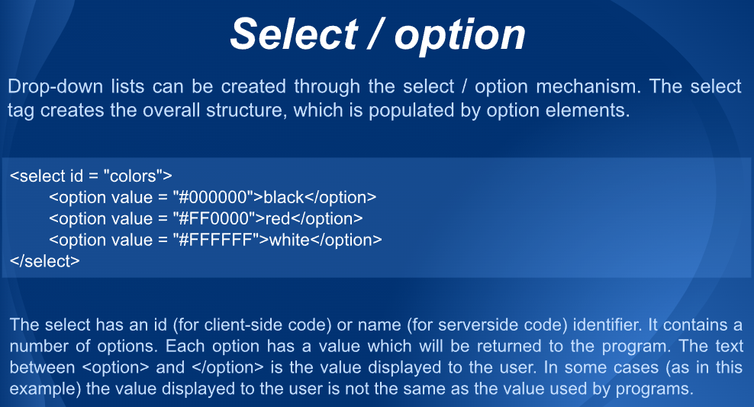

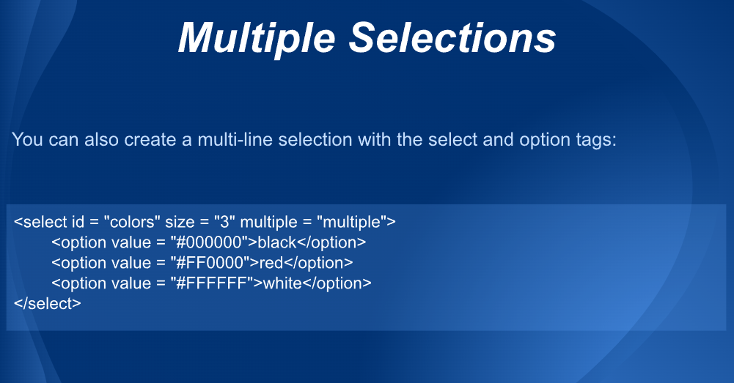

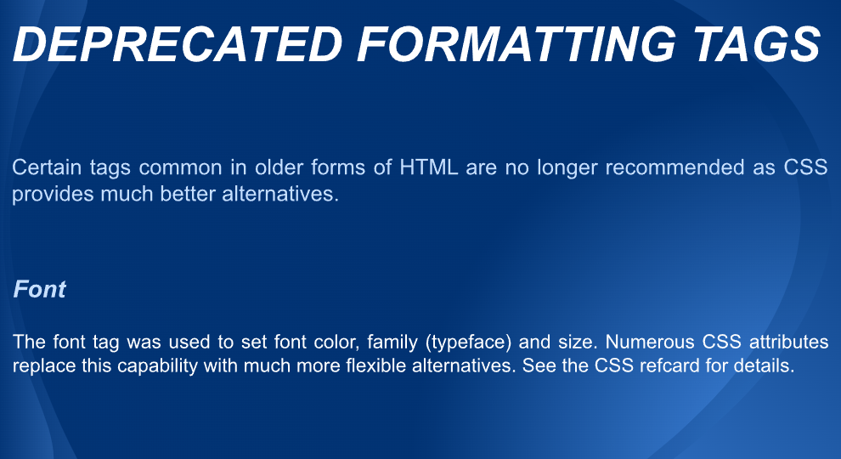

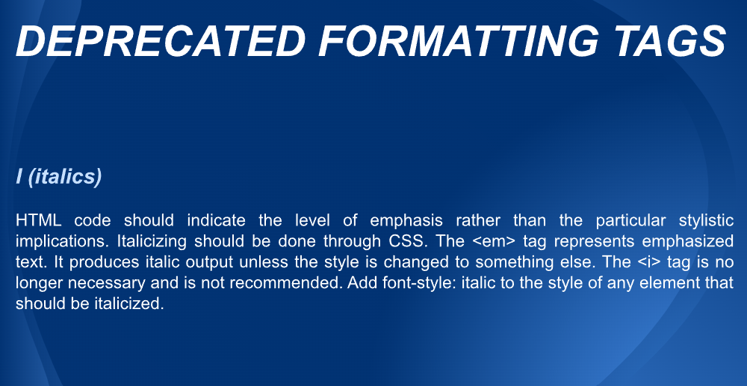

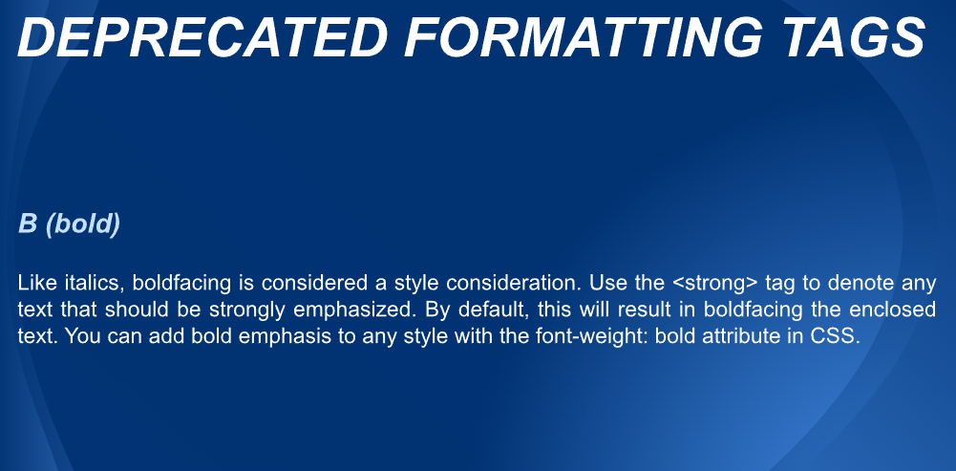

HTML5:

HTML5 New Tags

Following is the complete list of the newly added element with their descriptions.

|  |  |
| --- | --- |
| **Tag** | **Description** |
| Structural or Semantic Tags | |
| <article> | It defines the independent or self-contained content of a webpage. |
| <aside> | It defines the content which provide information about the main content. |
| <bdi> | It is used to isolate the part of text which might be formatted in another direction. |
| <details> | It defines additional information which only visible as per user demand. |
| <dialog> | It represents a dialog box or other interactive components. |
| <figcaption> | It defines caption for the <figure> element. |
| <figure> | It defines a self-contained content, and referenced as a single unit. |
| <footer> | It represents the footer section of the webpage. |
| <header> | It defines the introductory or navigational content of the webpage. |
| <main> | It specifies the main content of the HTML document. |
| <mark> | It represent the text which is highlighted or marked for reference or notation purposes. |
| <meter> | It represents a scalar value within a known range. |
| <nav> | It represents the section which contains navigation links. |
| <progress> | It defines a progress bar which shows completions progress of a task. |
| <rp> | It defines alternative content for the browser which do not support ruby annotations. |
| <rt> | It defines explanations and pronunciations of characters in ruby annotations. |
| <ruby> | It defines ruby annotations (Specifically for Asian language). |
| <section> | It defines a generic section within an HTML document. |
| <summary> | It defines summary or caption for a <details> element which can be clicked to change the state of <details> element. |
| <time> | It defines data/time within an HTML document. |
| <wbr> | It specifies a line break opportunity. (Where line break possible) |
| HTML5 Form Tags | |
|  |  |
| <datalist> | It represent predefined list for input <option> element. |
| <output> | It is used a container element to represent the output of a calculation or outcome of user action. |
| Graphics Tags | |
|  |  |
| <canvas> | It allows drawing graphics and animations via scripting. |
| <svg> | It is used to draw scalable vector graphics. |
| HTML5 Media Tags | |
|  |  |
| <audio> | It defines sound content. |
| <embed> | It defines a container for external files/application/media. |
| <source> | It defines multiple media resources for the media elements. |
| <track> | It defines text tracks for <audio> and <video> files |
| <video> | It defines video content within HTML document. |

HTML5 New <input> types

|  |  |
| --- | --- |
| **Type** | **Description** |
| color | It represents an input field which defines a color selector. |
| date | It represents an input field to define a date selector. |
| datetime | It defines full date and time display with time zone information. |
| datetime-local | It defines date and time without time zone information. |
| email | It defines an input field with email pattern Validation. |
| month | It defines the input field to enter month for the particular year |
| number | It defines field which selects a numeric value only. |
| range | It defines a numeric value selector with a given range of 1 to 100. |
| search | It is used to define a search field. |
| tel | It represents a control to enter a telephone number. |
| time | It represents a control to enter time value with no time zone. |
| url | It represents an input field to enter a URL |
| week | It defines a selector for week value for the particular year. |